|  |  |  |
| --- | --- | --- |
| **Supervisor.** | **Miss Wajiha Siddiqui** | |
| **Batch.** | **2310C2** | |
| **Group.** | **D** | |
| **Serial No.** | **Enrollment Number** | **Student Name** |
| 1. | Student-1527771 | Syed Hamza Imran Hussain |

**Shrek Juice**

**Acknowledgment**

Before anything, I would like to thanks my beloved Miss Wajiha Siddique who helped us a lot in reviewing this project within the limited time frame.

Secondly, we would also like to thank the E-Project team at Aptech Head Office, who gave us the golden opportunity to do this wonderful project about Nexus Aquarium.

Thirdly, we also thank the E-Project team, some of the benefits are as under: Re-Enforcement of skills happens in the experiential learning process. ∙ A mentor, ensuring that we do not get drifted, constantly guides us. ∙ It gives us a lot of confidence to face an interview as we have worked on a project. We can explain virtually everything on the subject

**SYNOPSIS**

"Embark on a flavorful journey with 'Shrek Juice,' a whimsical online juice emporium that blends the magic of nature with the allure of innovation. Led by the visionary Sophia Meadows, 'Shrek Juice' isn't just a destination for premium, handcrafted juices; it's a celebration of health, sustainability, and creativity.”

**PROBLEM DEFINITION**

'Shrek Juice' aims to establish itself as a go-to destination for events and workshops centered around health and wellness. The website should serve as a platform for promoting these events and engaging with the community

**CUSTOMER REQUIREMENT**

**SPECIFICATION (CRS)**

The Web site is to be created based on the following requirements.

1) The Home Page should be created making use of Sections with a suitable logo

2) Few tips can be included in the blank space area of the webpage.

3) The Menus must be included in the website.

4) Links such as

- Products and Menu

i. Fruit juices

ii. Vegetable Juices

iii. Smoothies

iv. Protein Shakes

v. Winter Menu

vi. Chocolate Juices

vii. Mock Tails

- Store Location

- Franchising

- Catering

- Contact

- Feedback

- About us

***SCOPE OF THE WORK (IN BRIEF)***

The website is to be developed for the Windows Platform using HTML5,

CSS3 JavaScript and bootstrap. The site should work well in all leading browsers including Chrome, Firefox etc. Our welcome page icon is re-directed to the main web page Ever essential content direct to relative content.

***Screenshots***

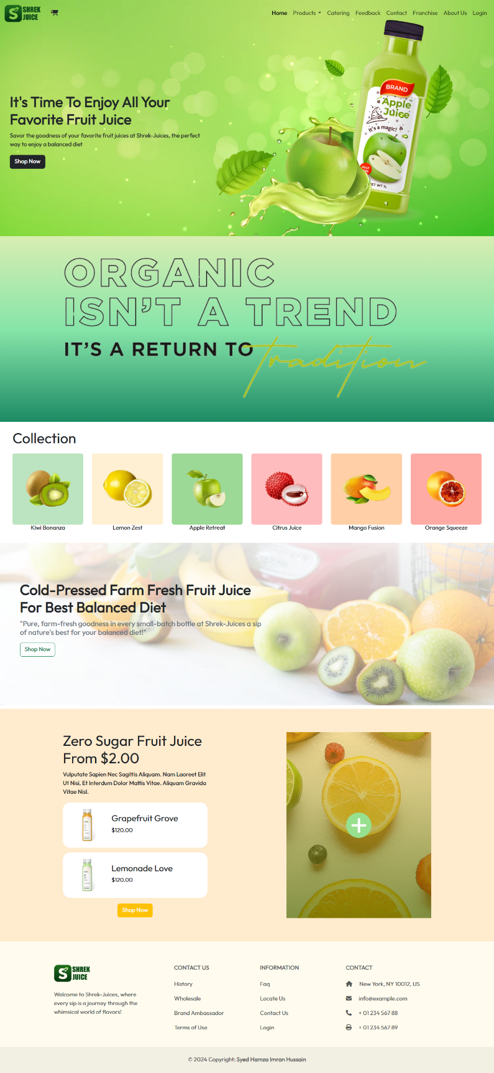

**Home**

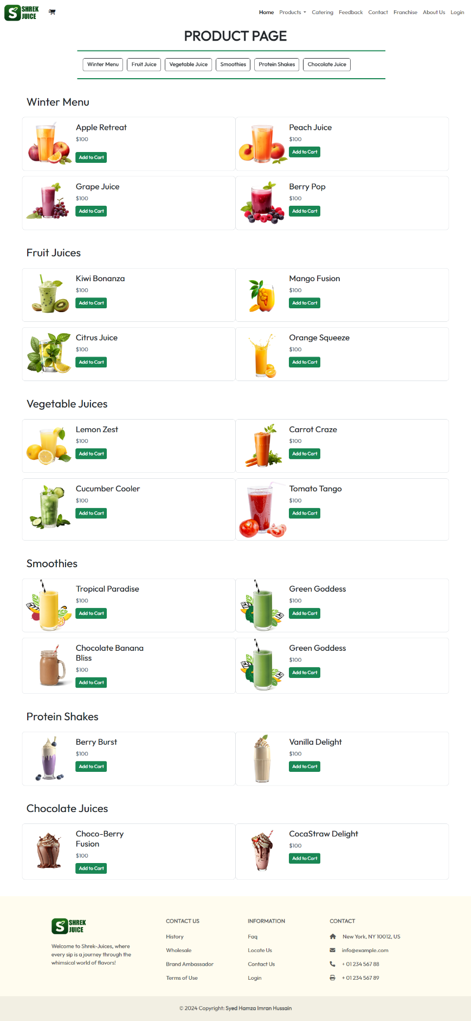

**Product**

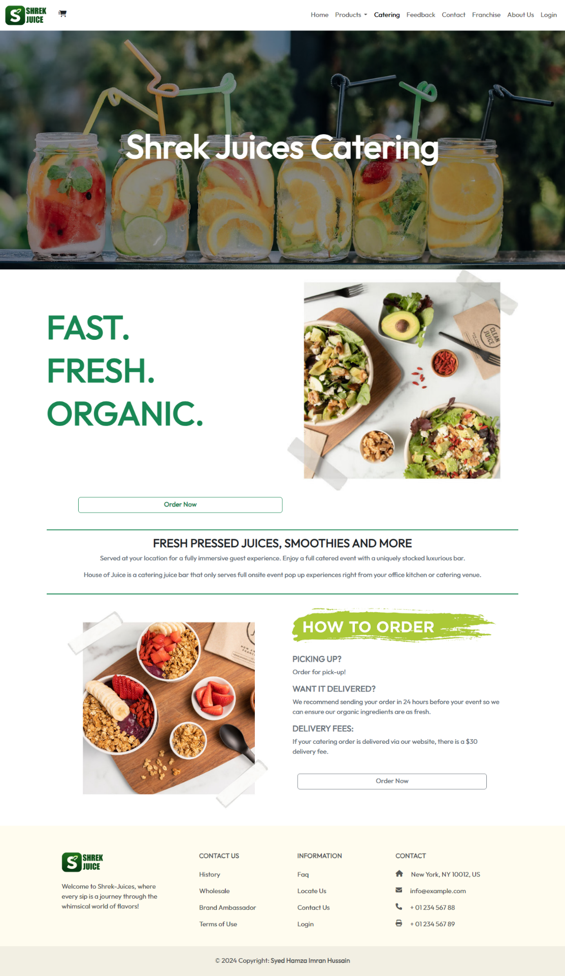

**Catering**

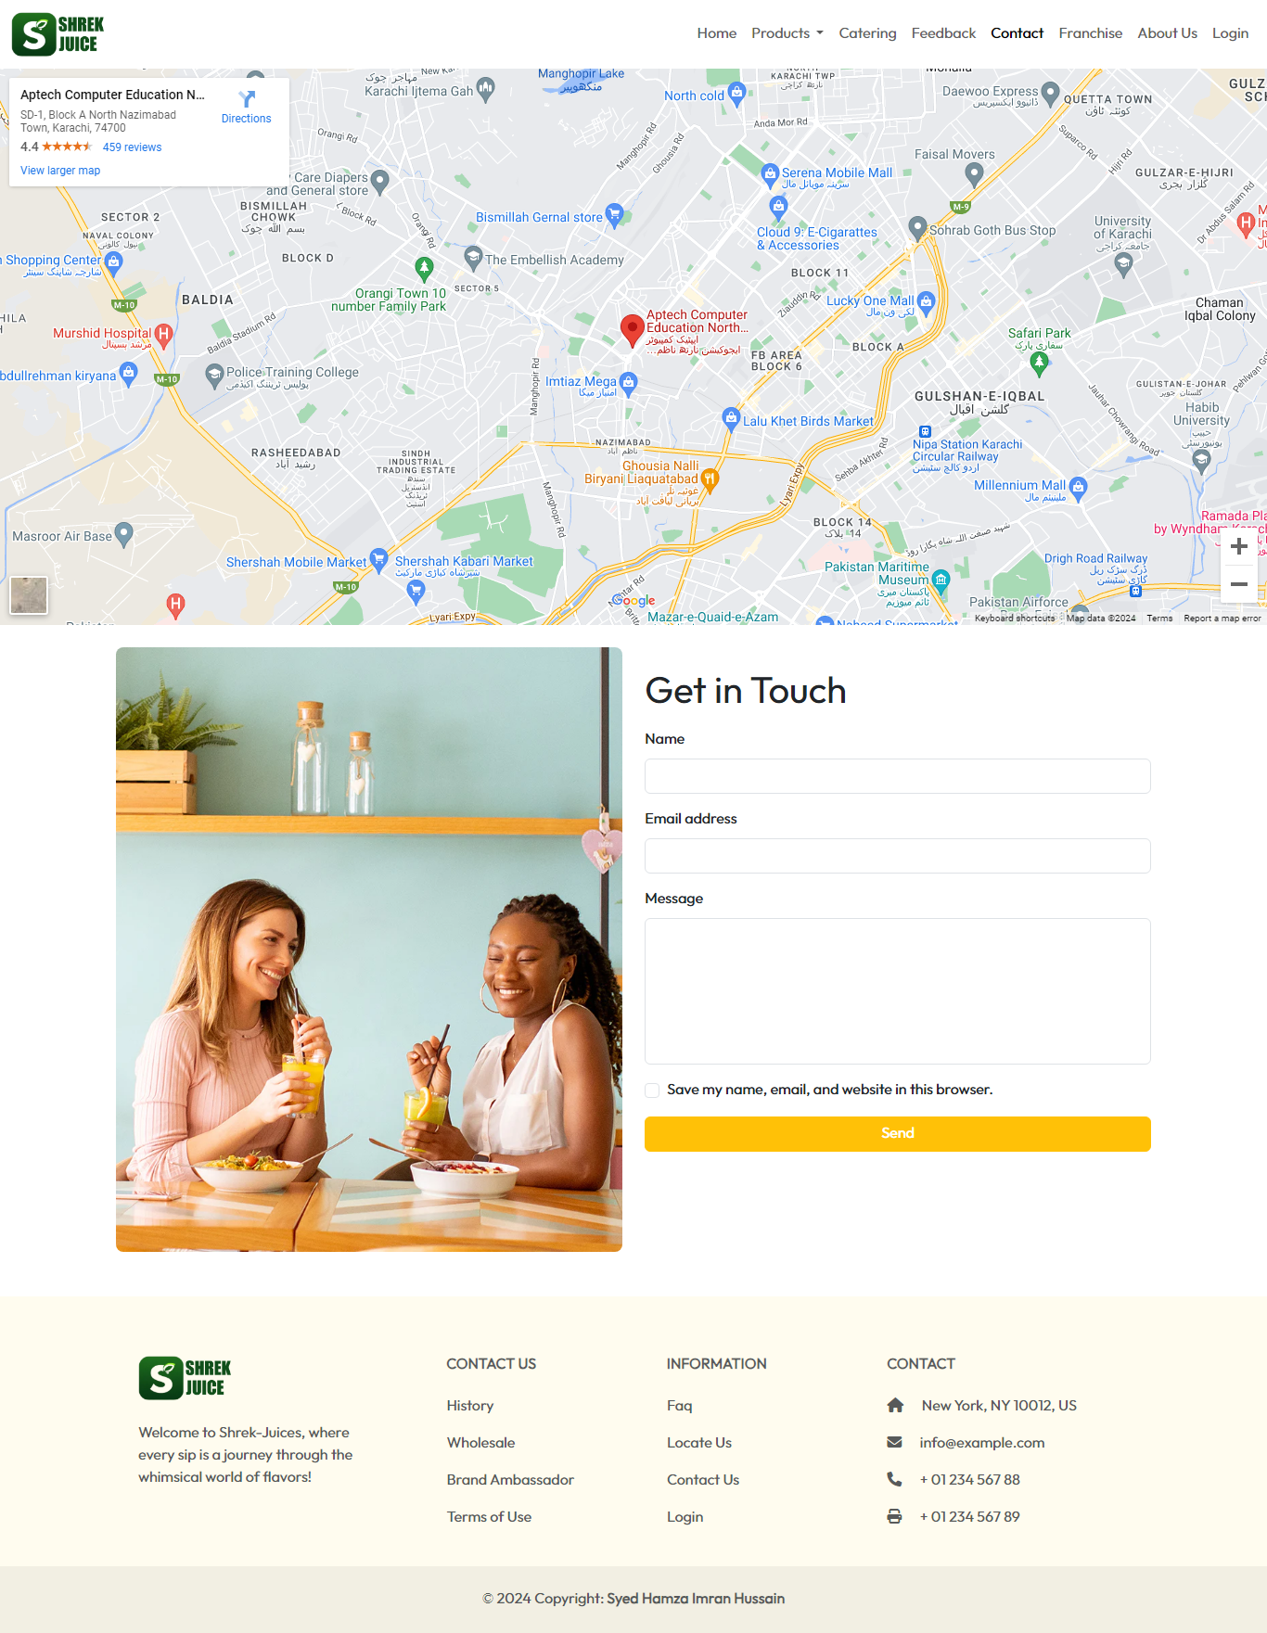

**Contact Us**

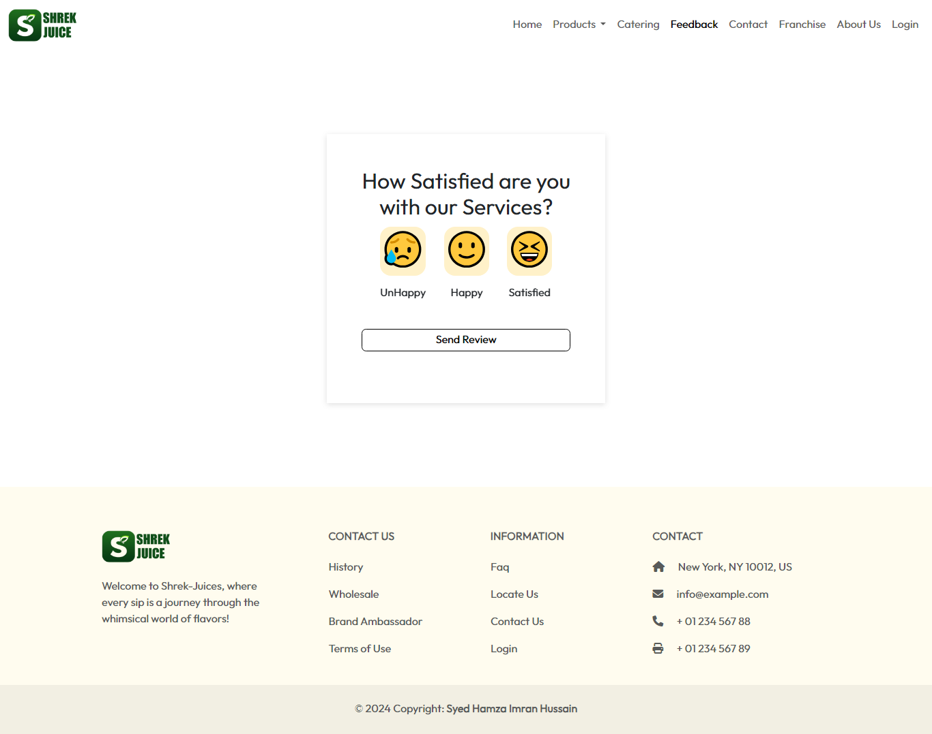

**Feedback**

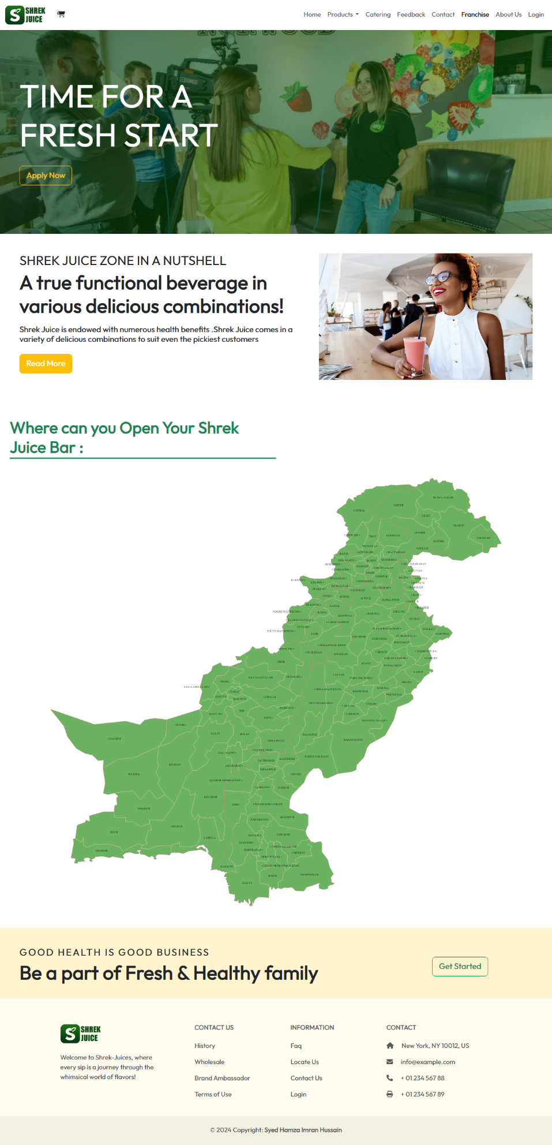

**Franchise**

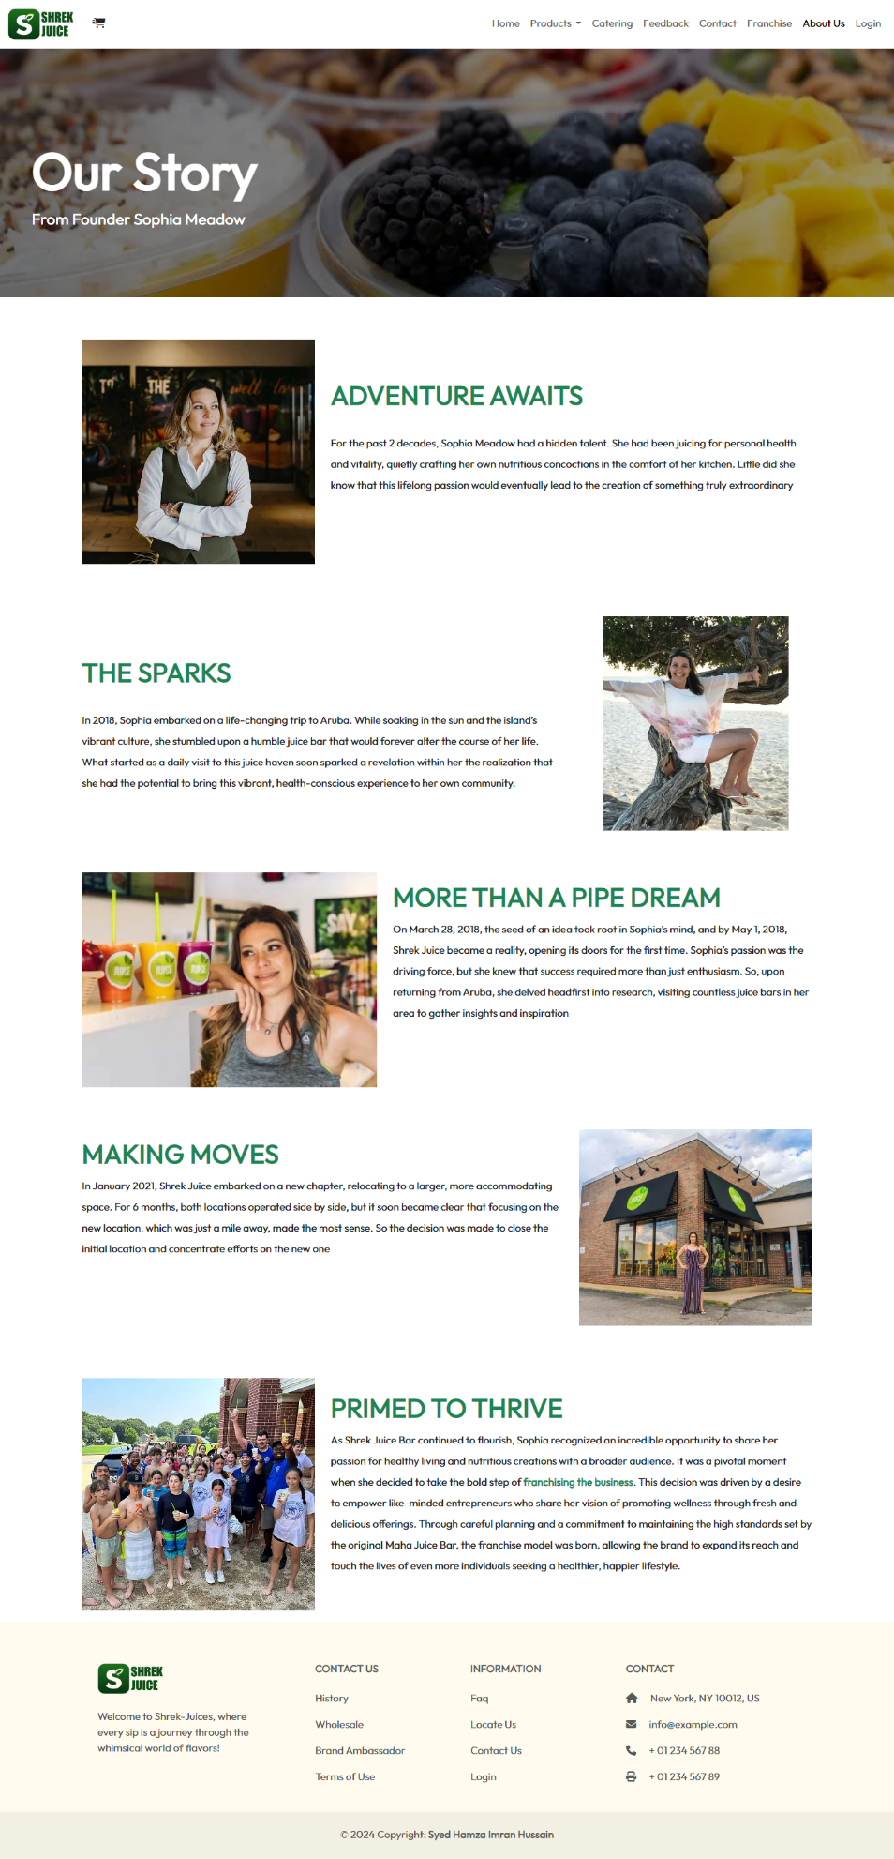

**About Us**

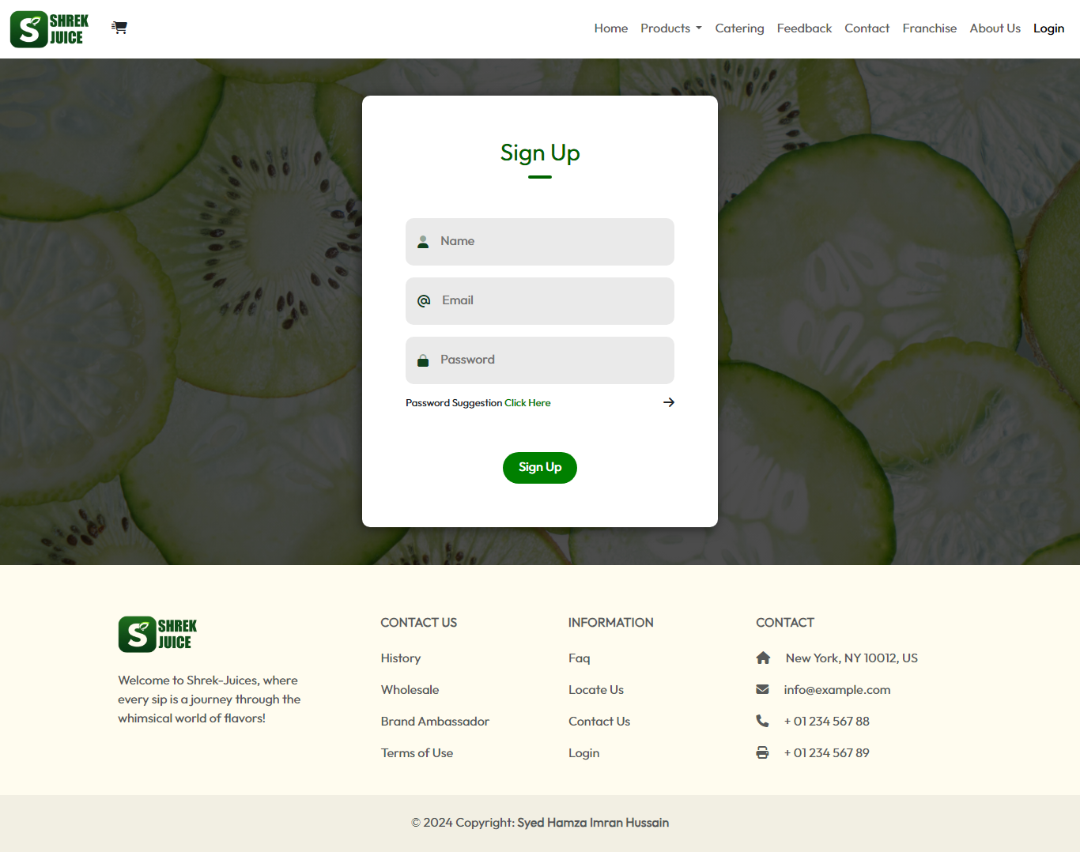

**Sign Up**